Tietokanta

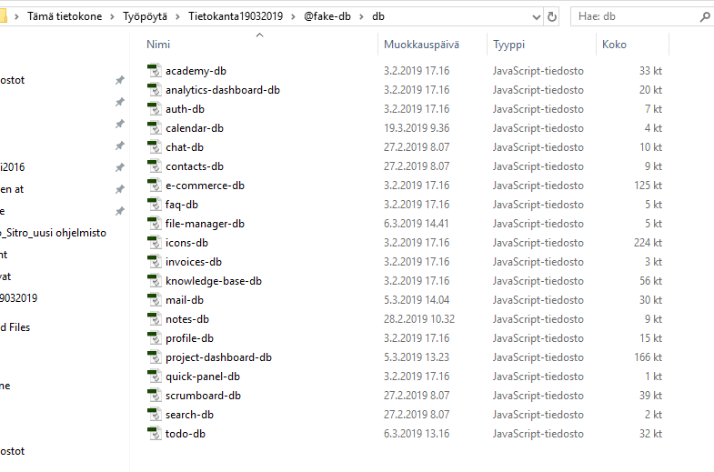

Viisi fileä

_create

_delete

_read

_update

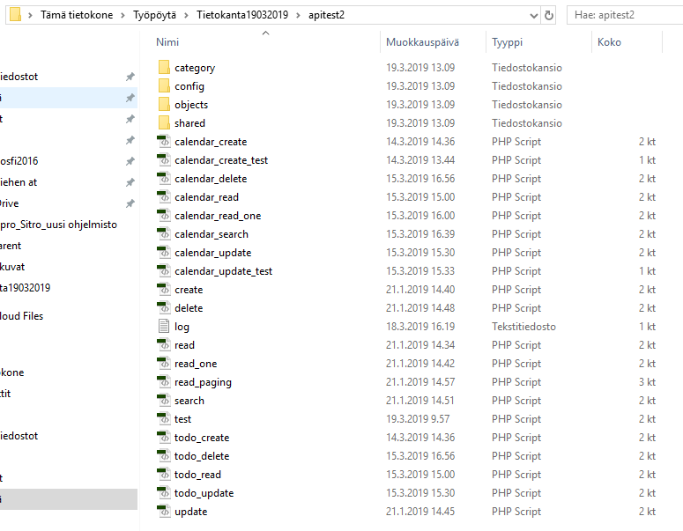

Yksi file

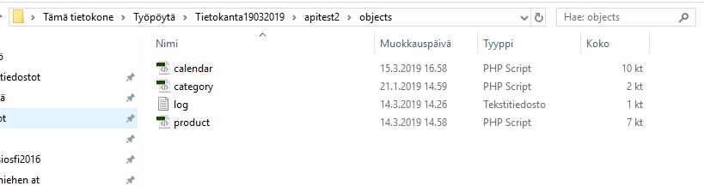

Sitro.sql stä löytyy tarvittavat tietueet

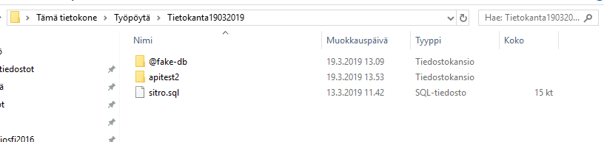

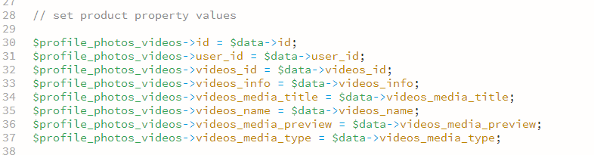

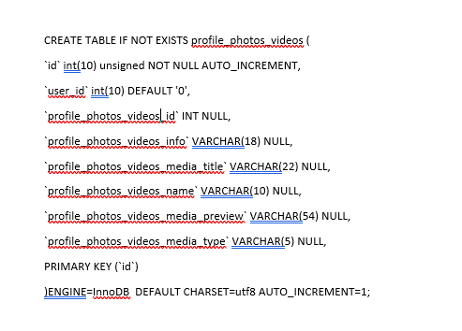

OIKEA TAPA

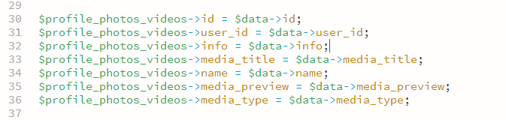

TOMMIN OHJE: OTSIKKO PUNAISELLA KUN TEHTY

CREATE TABLE IF NOT EXISTS `calendar` (

`calendar_desc` VARCHAR(35) NULL,

`calendar_id` int(10) unsigned NOT NULL AUTO_INCREMENT,

`calendar_title` VARCHAR(10) NULL,

`calendar_start` int(10) DEFAULT '0',

`calendar_end` int(10) DEFAULT '0',

PRIMARY KEY (`calendar_id`)

) ENGINE=InnoDB DEFAULT CHARSET=utf8 AUTO_INCREMENT=1;

CREATE TABLE IF NOT EXISTS `chat` (

`id` int(10) unsigned NOT NULL AUTO_INCREMENT,

`chat_id` VARCHAR(24) NULL,

PRIMARY KEY (`id`)

)ENGINE=InnoDB DEFAULT CHARSET=utf8 AUTO_INCREMENT=1;

CREATE TABLE IF NOT EXISTS `chat_dialog` (

`chat_id` int(10) unsigned DEFAULT '0',

`chat_dialog_message` VARCHAR(96) NULL,

`chat_dialog_time` VARCHAR(24) NULL,

`chat_dialog_who` VARCHAR(24) NULL

)ENGINE=InnoDB DEFAULT CHARSET=utf8 AUTO_INCREMENT=1;

CREATE TABLE IF NOT EXISTS `chat_contacts` (

`id` int(10) unsigned NOT NULL AUTO_INCREMENT,

`user_id` int(10) unsigned DEFAULT '0',

`chat_contacts_avatar` VARCHAR(33) NULL,

`chat_contacts_id` VARCHAR(24) NULL,

`chat_contacts_mood` VARCHAR(58) NULL,

`chat_contacts_name` VARCHAR(7) NULL,

`chat_contacts_status` VARCHAR(14) NULL,

`chat_contacts_unread` INT NULL,

PRIMARY KEY (`id`)

)ENGINE=InnoDB DEFAULT CHARSET=utf8 AUTO_INCREMENT=1;

CREATE TABLE IF NOT EXISTS `chat_user` (

`id` int(10) unsigned NOT NULL AUTO_INCREMENT,

`chat_user_avatar` VARCHAR(33) NULL,

`chat_user_id` VARCHAR(24) NULL,

`chat_user_mood` VARCHAR(34) NULL,

`chat_user_name` VARCHAR(8) NULL,

`chat_user_status` VARCHAR(6) NULL,

PRIMARY KEY (`id`)

)ENGINE=InnoDB DEFAULT CHARSET=utf8 AUTO_INCREMENT=1;

CREATE TABLE IF NOT EXISTS `chat_user_chat_list` (

`id` int(10) unsigned NOT NULL AUTO_INCREMENT,

`user_id` int(10) unsigned DEFAULT '0',

`chat_id` int(10) unsigned DEFAULT '0',

`contact_id` int(10) unsigned DEFAULT '0',

`chat_user_chat_list_chat_id` VARCHAR(24) NULL,

`chat_user_chat_list_contact_id` VARCHAR(24) NULL,

`chat_user_chat_list_last_message_time` VARCHAR(24) NULL,

PRIMARY KEY (`id`)

)ENGINE=InnoDB DEFAULT CHARSET=utf8 AUTO_INCREMENT=1;

CREATE TABLE IF NOT EXISTS contacts ( AASIA TEKEE

`id` int(10) unsigned NOT NULL AUTO_INCREMENT,

`contacts_address` VARCHAR(39) NULL,

`contacts_avatar` VARCHAR(53) NULL,

`contacts_company` VARCHAR(10) NULL,

`contacts_email` VARCHAR(24) NULL,

`contacts_id` VARCHAR(24) NULL,

`contacts_job_title` VARCHAR(21) NULL,

`contacts_last_name` VARCHAR(10) NULL,

`contacts_name` VARCHAR(7) NULL,

`contacts_nickname` VARCHAR(10) NULL,

`contacts_notes` VARCHAR(0) NULL,

`contacts_phone` VARCHAR(15) NULL,

PRIMARY KEY (`id`)

)ENGINE=InnoDB DEFAULT CHARSET=utf8 AUTO_INCREMENT=1;

CREATE TABLE IF NOT EXISTS file_manager (

`file_manager_files_created` VARCHAR(12) NULL,

`file_manager_files_extention` VARCHAR(0) NULL,

`file_manager_files_id` int(10) unsigned NOT NULL AUTO_INCREMENT,

`file_manager_files_location` VARCHAR(20) NULL,

`file_manager_files_modified` VARCHAR(12) NULL,

`file_manager_files_name` VARCHAR(17) NULL,

`file_manager_files_opened` VARCHAR(12) NULL,

`file_manager_files_owner` VARCHAR(13) NULL,

`file_manager_files_preview` VARCHAR(41) NULL,

`file_manager_files_size` VARCHAR(6) NULL,

`file_manager_files_type` VARCHAR(8) NULL,

PRIMARY KEY (`file_manager_files_id`)

)ENGINE=InnoDB DEFAULT CHARSET=utf8 AUTO_INCREMENT=1;

CREATE TABLE IF NOT EXISTS mail (

`id` int(10) unsigned NOT NULL AUTO_INCREMENT,

`mail_id` VARCHAR(19) CHARACTER SET utf8,

`mail_from_name` VARCHAR(16) CHARACTER SET utf8,

`mail_from_avatar` VARCHAR(33) CHARACTER SET utf8,

`mail_from_email` VARCHAR(28) CHARACTER SET utf8,

`mail_to_name` VARCHAR(2) CHARACTER SET utf8,

`mail_to_email` VARCHAR(20) CHARACTER SET utf8,

`mail_subject` VARCHAR(87) CHARACTER SET utf8,

`mail_message` INT (10) default 0,

`mail_time` VARCHAR(6) CHARACTER SET utf8,

`mail_read` VARCHAR(5) CHARACTER SET utf8,

`mail_starred` VARCHAR(5) CHARACTER SET utf8,

`mail_important` VARCHAR(5) CHARACTER SET utf8,

`mail_hasAttachments` VARCHAR(5) CHARACTER SET utf8,

PRIMARY KEY (`id`)

)ENGINE=InnoDB DEFAULT CHARSET=utf8 AUTO_INCREMENT=1;

CREATE TABLE IF NOT EXISTS mail_attachments (

`id` int(10) unsigned NOT NULL AUTO_INCREMENT,

`mail_id` int(10) unsigned DEFAULT '0',

`mail_attachments_type` VARCHAR(5) CHARACTER SET utf8,

`mail_attachments_fileName` VARCHAR(7) CHARACTER SET utf8,

`mail_attachments_preview` VARCHAR(35) CHARACTER SET utf8,

`mail_attachments_url` VARCHAR(25) NULL,

`mail_attachments_size` VARCHAR(5) CHARACTER SET utf8,

`mail_labels` INT (10) default 0,

`mail_folder` INT (10) default 0,

PRIMARY KEY (`id`)

)ENGINE=InnoDB DEFAULT CHARSET=utf8 AUTO_INCREMENT=1;

CREATE TABLE IF NOT EXISTS mail_folders (

`folders_id` INT (10),

`folders_handle` VARCHAR(6) CHARACTER SET utf8,

`folders_title` VARCHAR(6) CHARACTER SET utf8,

`folders_icon` VARCHAR(10) CHARACTER SET utf8

)ENGINE=InnoDB DEFAULT CHARSET=utf8 AUTO_INCREMENT=1;

CREATE TABLE IF NOT EXISTS mail_filters (

`filters_id` INT (10),

`filters_handle` VARCHAR(9) CHARACTER SET utf8,

`filters_title` VARCHAR(9) CHARACTER SET utf8,

`filters_icon` VARCHAR(5) CHARACTER SET utf8

)ENGINE=InnoDB DEFAULT CHARSET=utf8 AUTO_INCREMENT=1;

CREATE TABLE IF NOT EXISTS mail_labels (

`labels_id` INT (10),

`labels_handle` VARCHAR(7) CHARACTER SET utf8,

`labels_title` VARCHAR(7) CHARACTER SET utf8,

`labels_color` VARCHAR(7) CHARACTER SET utf8

)ENGINE=InnoDB DEFAULT CHARSET=utf8 AUTO_INCREMENT=1;

CREATE TABLE IF NOT EXISTS `notes` (

`id` int(10) unsigned NOT NULL AUTO_INCREMENT,

`notes_description` VARCHAR(34) NULL,

`notes_id` VARCHAR(24) NULL,

`notes_image` VARCHAR(30) NULL,

`notes_reminder` VARCHAR(24) NULL,

`notes_time` VARCHAR(24) NULL,

`notes_title` VARCHAR(34) NULL,

`notes_nlabels` VARCHAR(24) NULL,

`notes_user` int(10) DEFAULT '0',

PRIMARY KEY (`id`)

)ENGINE=InnoDB DEFAULT CHARSET=utf8 AUTO_INCREMENT=1;

CREATE TABLE IF NOT EXISTS `notes_checklist` (

`id` int(10) unsigned NOT NULL AUTO_INCREMENT,

`notes_checklist_id` INT NULL,

`notes_id` INT NULL,

`notes_checklist_text` VARCHAR(36) NULL,

PRIMARY KEY (`id`)

)ENGINE=InnoDB DEFAULT CHARSET=utf8 AUTO_INCREMENT=1;

CREATE TABLE IF NOT EXISTS `notes_labels` (

`id` int(10) unsigned NOT NULL AUTO_INCREMENT,

`notes_labels_handle` VARCHAR(8) NULL,

`notes_labels_id` VARCHAR(24) NULL,

`notes_labels_name` VARCHAR(8) NULL,

PRIMARY KEY (`id`)

)ENGINE=InnoDB DEFAULT CHARSET=utf8 AUTO_INCREMENT=1;

CREATE TABLE IF NOT EXISTS profile_about (

`id` int(10) unsigned NOT NULL AUTO_INCREMENT,

`user_id` int(10) DEFAULT '0',

`profile_about_contact_address` VARCHAR(121) NULL,

`profile_about_groups_category` VARCHAR(10) NULL,

`profile_about_work_jobs_date` VARCHAR(11) NULL,

`profile_about_general_locations` VARCHAR(13) NULL,

`profile_about_groups_members` VARCHAR(9) NULL,

`profile_about_friends_avatar` VARCHAR(33) NULL,

`profile_about_friends_id` INT NULL,

`profile_about_general_about` VARCHAR(289) NULL,

`profile_about_work_jobs_company` VARCHAR(13) NULL,

`profile_about_contact_websites` VARCHAR(16) NULL,

`profile_about_friends_name` VARCHAR(14) NULL,

`profile_about_groups_id` INT NULL,

`profile_about_general_gender` VARCHAR(4) NULL,

`profile_about_work_occupation` VARCHAR(9) NULL,

`profile_about_contact_emails` VARCHAR(21) NULL,

`profile_about_groups_name` VARCHAR(7) NULL,

`profile_about_general_birthday` VARCHAR(19) NULL,

`profile_about_contact_tel` VARCHAR(11) NULL,

`profile_about_work_skills` VARCHAR(43) NULL,

PRIMARY KEY (`id`)

)ENGINE=InnoDB DEFAULT CHARSET=utf8 AUTO_INCREMENT=1;

CREATE TABLE IF NOT EXISTS profile_photos_videos (

`id` int(10) unsigned NOT NULL AUTO_INCREMENT,

`user_id` int(10) DEFAULT '0',

`profile_photos_videos_id` INT NULL,

`profile_photos_videos_info` VARCHAR(18) NULL,

`profile_photos_videos_media_title` VARCHAR(22) NULL,

`profile_photos_videos_name` VARCHAR(10) NULL,

`profile_photos_videos_media_preview` VARCHAR(54) NULL,

`profile_photos_videos_media_type` VARCHAR(5) NULL,

PRIMARY KEY (`id`)

)ENGINE=InnoDB DEFAULT CHARSET=utf8 AUTO_INCREMENT=1;

CREATE TABLE IF NOT EXISTS profile_timeline (

`id` int(10) unsigned NOT NULL AUTO_INCREMENT,

`user_id` int(10) DEFAULT '0',

`profile_timeline_posts_share` INT NULL,

`profile_timeline_posts_article_media_type` VARCHAR(5) NULL,

`profile_timeline_posts_message` VARCHAR(216) NULL,

`profile_timeline_posts_media_preview` VARCHAR(37) NULL,

`profile_timeline_posts_id` INT NULL,

`profile_timeline_posts_article_media_preview

` VARCHAR(45) NULL,

`profile_timeline_activities_user_avatar` VARCHAR(33) NULL,

`profile_timeline_posts_comments_message` VARCHAR(195) NULL,

`profile_timeline_posts_media_type` VARCHAR(5) NULL,

`profile_timeline_posts_comments_user_avatar` VARCHAR(31) NULL,

`profile_timeline_posts_comments_id` INT NULL,

`profile_timeline_activities_time` VARCHAR(12) NULL,

`profile_timeline_posts_time` VARCHAR(14) NULL,

`profile_timeline_posts_like` INT NULL,

`profile_timeline_activities_user_name` VARCHAR(14) NULL,

`profile_timeline_posts_user_avatar` VARCHAR(32) NULL,

`profile_timeline_posts_article_title` VARCHAR(20) NULL,

`profile_timeline_posts_article_subtitle` VARCHAR(13) NULL,

`profile_timeline_posts_comments_time` VARCHAR(13) NULL,

`profile_timeline_activities_message` VARCHAR(39) NULL,

`profile_timeline_posts_user_name` VARCHAR(14) NULL,

`profile_timeline_activities_id` INT NULL,

`profile_timeline_posts_type` VARCHAR(9) NULL,

`profile_timeline_posts_comments_user_name` VARCHAR(13) NULL,

`profile_timeline_posts_article_excerpt` VARCHAR(136) NULL,

PRIMARY KEY (`id`)

)ENGINE=InnoDB DEFAULT CHARSET=utf8 AUTO_INCREMENT=1;

CREATE TABLE IF NOT EXISTS scrumboard (

`id` int(10) unsigned NOT NULL AUTO_INCREMENT,

`scrumboard_boards_name` VARCHAR(25) NULL,

`scrumboard_boards_id` VARCHAR(8) NULL,

`scrumboard_boards_uri` VARCHAR(25) NULL,

PRIMARY KEY (`id`)

)ENGINE=InnoDB DEFAULT CHARSET=utf8 AUTO_INCREMENT=1;

CREATE TABLE IF NOT EXISTS scrumboard_settings(

`board_id` int(10) unsigned DEFAULT '0',

`scrumboard_boards_settings_color` VARCHAR(9) NULL,

`scrumboard_boards_settings_subscribed` tinyint(1) default 0,

`scrumboard_boards_settings_cardCoverImages` tinyint(1) default 0

)ENGINE=InnoDB DEFAULT CHARSET=utf8 AUTO_INCREMENT=1;

CREATE TABLE IF NOT EXISTS scrumboard_boards_lists (

`id` int(10) unsigned NOT NULL AUTO_INCREMENT,

`board_id` int(10) unsigned DEFAULT '0',

`scrumboard_boards_lists_id` VARCHAR(84) NULL,

`scrumboard_boards_lists_name` VARCHAR(17) NULL,

`scrumboard_boards_lists_id_cards` VARCHAR(84) NULL,

PRIMARY KEY (`id`)

)ENGINE=InnoDB DEFAULT CHARSET=utf8 AUTO_INCREMENT=1;

CREATE TABLE IF NOT EXISTS scrumboard_boards_cards (

`id` int(10) unsigned NOT NULL AUTO_INCREMENT,

`list_id` int(10) unsigned DEFAULT '0',

`scrumboard_boards_cards_due` VARCHAR(24) NULL,

`scrumboard_boards_cards_id` VARCHAR(84) NULL,

`scrumboard_boards_cards_name` VARCHAR(36) NULL,

`scrumboard_boards_cards_description` VARCHAR(104) NULL,

`scrumboard_boards_cards_activities_id` INT NULL,

`scrumboard_boards_cards_attachments_type` VARCHAR(5) NULL,

`scrumboard_boards_cards_id_members` VARCHAR(24) NULL,

`scrumboard_boards_cards_id_labels` VARCHAR(24) NULL,

PRIMARY KEY (`id`)

)ENGINE=InnoDB DEFAULT CHARSET=utf8 AUTO_INCREMENT=1;

CREATE TABLE IF NOT EXISTS scrumboard_attachments (

`id` int(10) unsigned NOT NULL AUTO_INCREMENT,

`card_id` int(10) unsigned DEFAULT '0',

`scrumboard_boards_cards_attachments_id` VARCHAR(24) NULL,

`scrumboard_boards_cards_id_attachment_cover` VARCHAR(24) NULL,

`scrumboard_boards_cards_attachments_src` VARCHAR(37) NULL,

`scrumboard_boards_cards_attachments_name` VARCHAR(23) NULL,

`scrumboard_boards_cards_attachments_url` VARCHAR(37) NULL,

`scrumboard_boards_cards_attachments_time` VARCHAR(22) NULL,

PRIMARY KEY (`id`)

)ENGINE=InnoDB DEFAULT CHARSET=utf8 AUTO_INCREMENT=1;

CREATE TABLE IF NOT EXISTS scrumboard_activities (

`id` int(10) unsigned NOT NULL AUTO_INCREMENT,

`card_id` int(10) unsigned DEFAULT '0',

`scrumboard_boards_cards_activities_time` VARCHAR(12) NULL,

`scrumboard_boards_cards_activities_id_member` VARCHAR(24) NULL,

`scrumboard_boards_cards_activities_type` VARCHAR(10) NULL,

`scrumboard_boards_cards_activities_message` VARCHAR(97) NULL,

PRIMARY KEY (`id`)

)ENGINE=InnoDB DEFAULT CHARSET=utf8 AUTO_INCREMENT=1;

CREATE TABLE IF NOT EXISTS scrumboard_checklists (

`id` int(10) unsigned NOT NULL AUTO_INCREMENT,

`card_id` int(10) unsigned DEFAULT '0',

`scrumboard_boards_cards_checklists_name` VARCHAR(14) NULL,

`scrumboard_boards_cards_checklists_check_items_name` VARCHAR(66) NULL,

`scrumboard_boards_cards_checklists_check_items_id` INT NULL,

`scrumboard_boards_cards_checklists_id` VARCHAR(84) NULL,

PRIMARY KEY (`id`)

)ENGINE=InnoDB DEFAULT CHARSET=utf8 AUTO_INCREMENT=1;

CREATE TABLE IF NOT EXISTS scrumboard_members (

`id` int(10) unsigned NOT NULL AUTO_INCREMENT,

`board_id` int(10) unsigned DEFAULT '0',

scrumboard_boards_members_id VARCHAR(24) NULL,

scrumboard_boards_members_name VARCHAR(15) NULL,

scrumboard_boards_members_avatar VARCHAR(35) NULL,

PRIMARY KEY (`id`)

)ENGINE=InnoDB DEFAULT CHARSET=utf8 AUTO_INCREMENT=1;

CREATE TABLE IF NOT EXISTS scrumboard_labels (

`id` int(10) unsigned NOT NULL AUTO_INCREMENT,

`board_id` int(10) unsigned DEFAULT '0',

`scrumboard_boards_labels_id` VARCHAR(24) NULL,

`scrumboard_boards_labels_class` VARCHAR(20) NULL,

`scrumboard_boards_labels_name` VARCHAR(13) NULL,

PRIMARY KEY (`id`)

)ENGINE=InnoDB DEFAULT CHARSET=utf8 AUTO_INCREMENT=1;

CREATE TABLE IF NOT EXISTS todo (

`id` int(10) unsigned NOT NULL AUTO_INCREMENT,

`todo_id` VARCHAR(24) NULL,

`todo_notes` VARCHAR(104) NULL,

`todo_title` VARCHAR(38) NULL,

`todo_startdate` int(10) DEFAULT '0',

`todo_duedate` int(10) DEFAULT '0',

`todo_completed` tinyint(1) unsigned DEFAULT NULL,

`todo_starred` tinyint(1) unsigned DEFAULT NULL,

`todo_important` tinyint(1) unsigned DEFAULT NULL,

`todo_deleted` tinyint(1) unsigned DEFAULT NULL,

`todo_labels` text,

`todo_user` int(10) DEFAULT '0',

PRIMARY KEY (`id`)

)ENGINE=InnoDB DEFAULT CHARSET=utf8 AUTO_INCREMENT=1;

CREATE TABLE IF NOT EXISTS todo_filters (

`id` int(10) unsigned NOT NULL AUTO_INCREMENT,

`todo_filters_handle` VARCHAR(9) NULL,

`todo_filters_icon` VARCHAR(8) NULL,

`todo_filters_id` INT NULL,

`todo_filters_title` VARCHAR(8) NULL,

PRIMARY KEY (`id`)

)ENGINE=InnoDB DEFAULT CHARSET=utf8 AUTO_INCREMENT=1;

CREATE TABLE IF NOT EXISTS todo_folders (

`id` int(10) unsigned NOT NULL AUTO_INCREMENT,

`todo_folders_handle` VARCHAR(3) NULL,

`todo_folders_icon` VARCHAR(13) NULL,

`todo_folders_id` INT NULL,

`todo_folders_title` VARCHAR(3) NULL,

PRIMARY KEY (`id`)

)ENGINE=InnoDB DEFAULT CHARSET=utf8 AUTO_INCREMENT=1;

CREATE TABLE IF NOT EXISTS todo_labels (

`id` int(10) unsigned NOT NULL AUTO_INCREMENT,

`todo_labels_color` VARCHAR(7) NULL,

`todo_labels_handle` VARCHAR(8) NULL,

`todo_labels_id` INT NULL,

`todo_labels_title` VARCHAR(8) NULL,

PRIMARY KEY (`id`)

)ENGINE=InnoDB DEFAULT CHARSET=utf8 AUTO_INCREMENT=1;

SITROON LISÄTTÄVÄ

Ne, joista en ole varma, tarvitseeko niitä tässä vaiheessa tai ylipäänsä lisätä on merkitty kysymysmerkillä.

Tehtävät

todo

Chat

chat

chat_dialog

chat_contacts

chat_user

chat_user_chat_list?

Tiedoston hallinta

file_manager

Muistiinpanot

notes

notes_checklist

notes_labels

Kortit

scrumboard

scrumboard_boards_lists

scrumboard_boards_cards

scrumboard_attachments?

scrumboard_activities?

scrumboard_checklists

scrumboard_members

scrumboard_labels

Profiili

profile?

Contacts

Aasia tekee